Chapter 10, Problem 47.

Determine i_{o} in the circuit of Fig. 10.92 using the superposition principle.

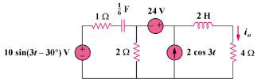
10sin(t – 30˚) V

Figure 10.92
For Prob. 10.47.

